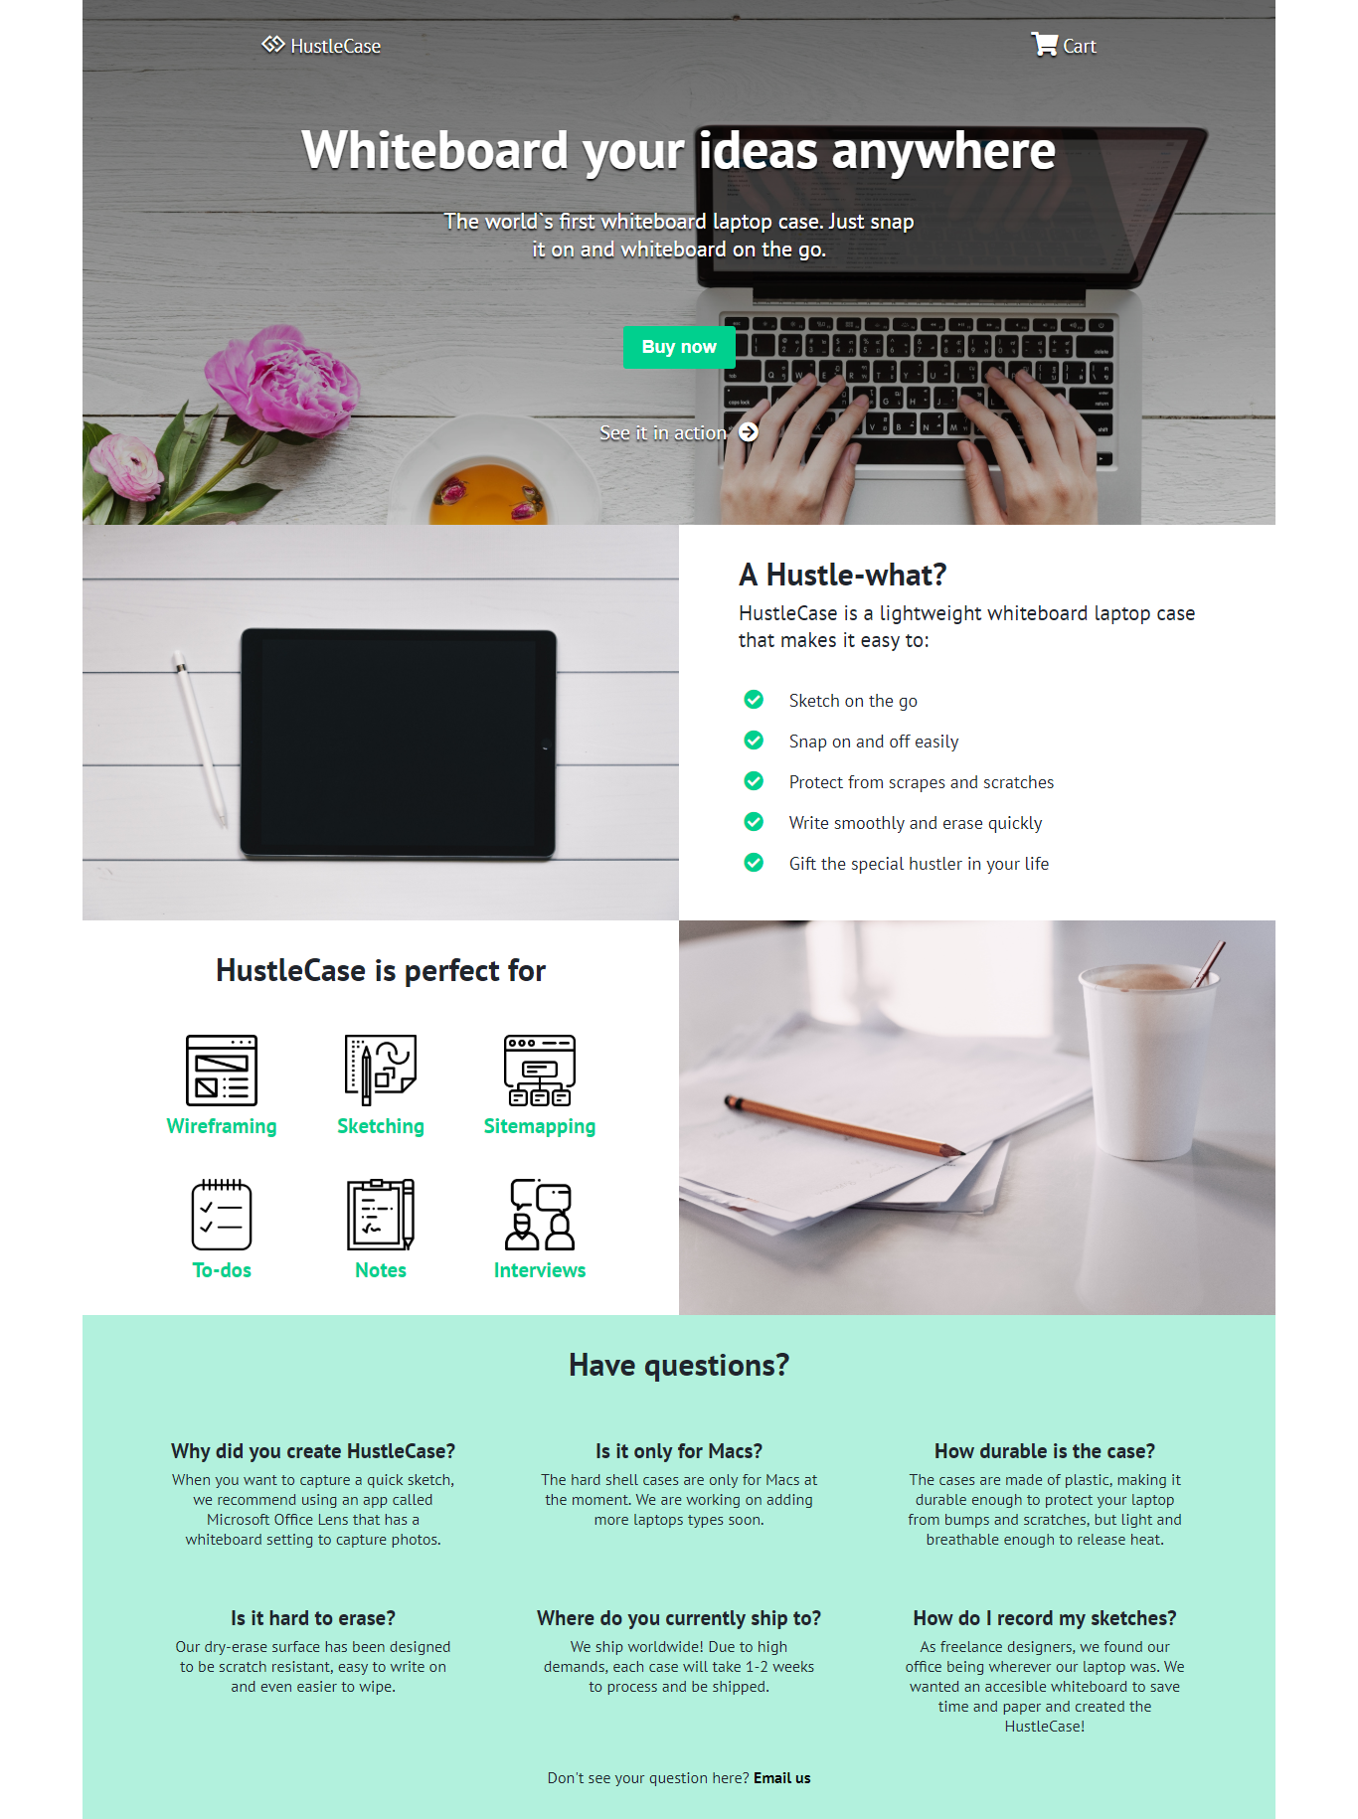

Whiteboard
Create a Web page (HTML5 + CSS3 + images) that looks and behaves like the screenshot below:
You are given the above screenshots + all required images.

Output
The output should be valid HTML5 + CSS3 + images that implement the above web page.

Constraints
- Use font - PT Sans
- Use Font Awesome for the icons – "gg" and "charshopping" icons
- The site should open correctly in the latest version of Chrome

